Richmond Cricket Club

Established

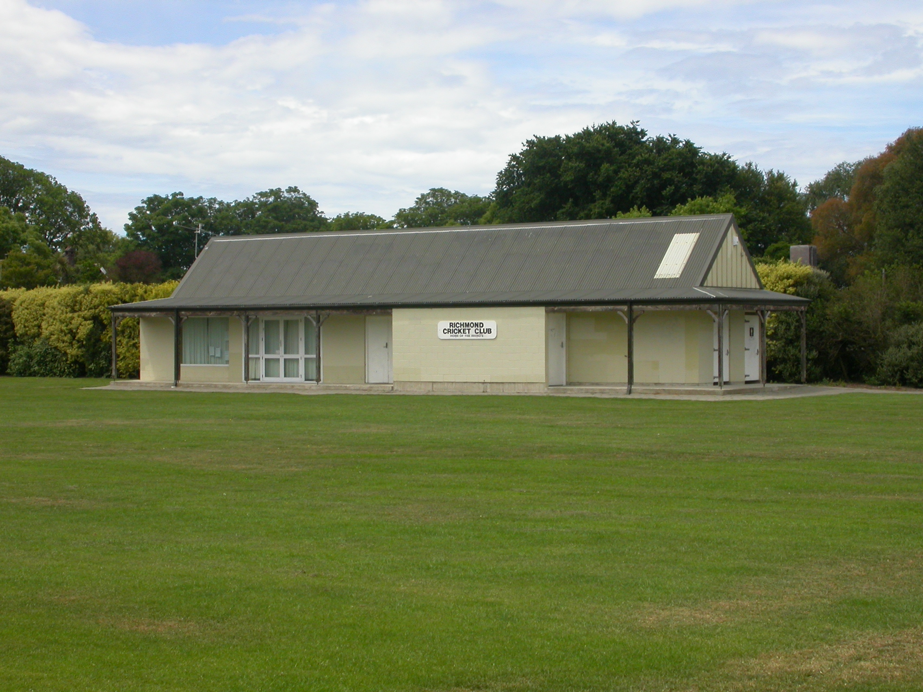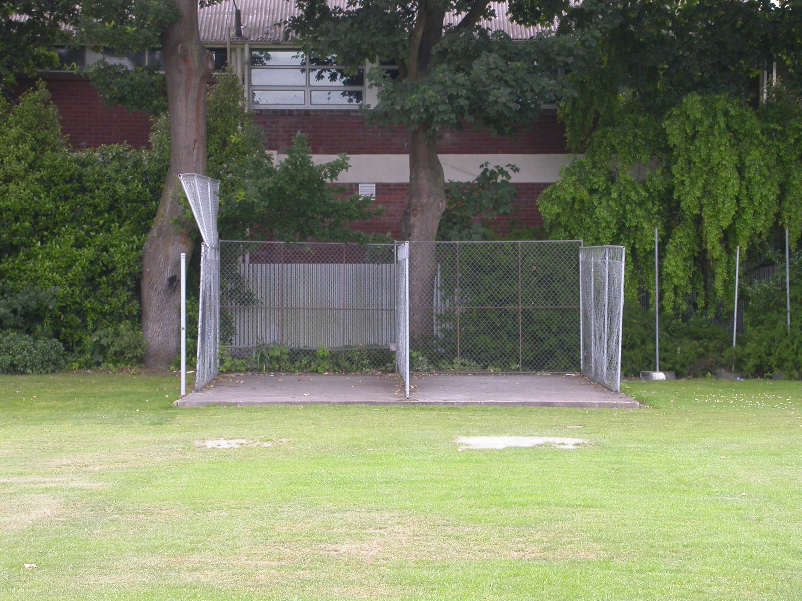

Home Ground Richmond Park
Match pitches 1 grass match pitches
Practice pitches 3 artificial pitches

Entries 2001-02 4 men teams
2002-03 4 men teams
2003-04 3 men teams
2004-05 3 men teams
2005/06 3 men teams

Grade wins last 5 years 2000-01 Senior B Third C
2001-02 Fourth D

